Setting up a GitHub repository with a circle-ci pipeline to run a SonarQube scan to check for hotspots and code smells.
the process of initially configuring and verifying CircleCI integration for a project.
The screenshot shows the CircleCI dashboard for our repository where automated pipelines are being set up and tested. The page lists recent pipeline runs triggered by commits or API calls.
Some runs failed because there was no .circleci/config.yml file was found in the project, meaning CircleCI didn’t know what steps to execute. Later runs succeeded after the configuration file was added, showing that the CI/CD setup is now functioning correctly.
The workflows shown (e.g., say-hello-workflow) ran simple test jobs that completed successfully in a few seconds.

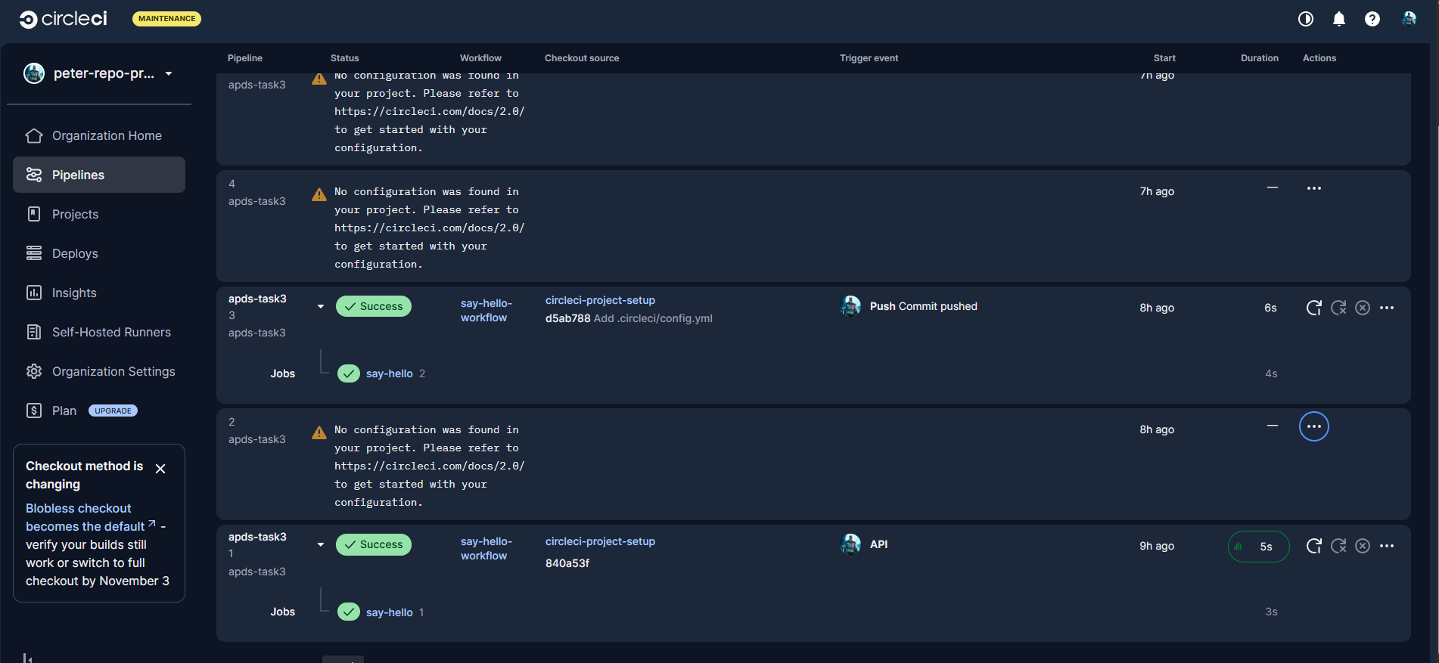

Github repo CicleCI set successfully

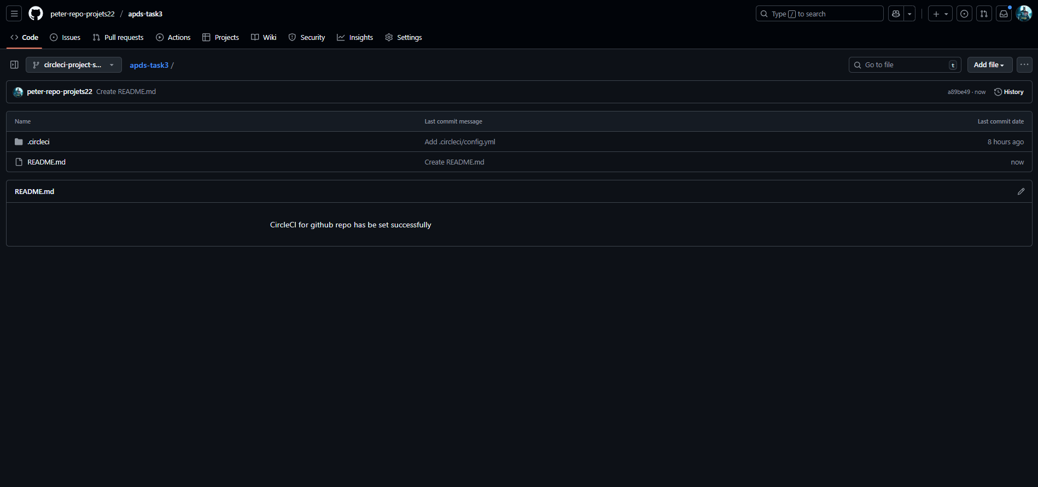
Set up circleCI + SonarQube Scan
